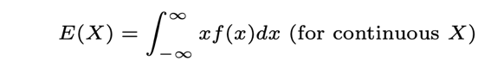
$E(X)=\int_{-∞}^{∞}{xf(x)dx}$

